H.U. MECHANICAL ENGINEERING

GENERAL CHEMISTRY LAB REPORT

STOICHIOMETRY

GÖKAY KART

21832009

KIM-121-6

ZÜHRA ÇINAR

Using the law of conservation of mass and the property of change, we will find out how many percent by mass of potassium chlorate (KCLO3) is in the mixture.

Stoichiometry deals with mass (sometimes volumetric) calculations between substances entering and leaving a chemical reaction. It is a quantitative study of reactants and products.

Mole is the unit of measure in SI for amount of substance. It is formed by the combination of avagadro’s number grain of atoms or molecules of a substance. Its unit is 'mol' and it is denoted by the letter 'n'.

Avogadro's number is the number of atoms in one mole of an element, or the number of molecules in one mole of a compound and its current value is;



Change of avagadro's number over time is;

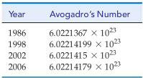

Amu, the basic mass measure of atomic dimensions is equal to 12/1 of the mass of the C-12 atom. It is also denoted by the letter "u" and its unit is "g".

**C-12 atom = 12 amu = 12 u / 1 amu = 1.6605 x 10-24 g**

**Anatomy of a chemical reaction;**

• Reactants are written on the left side of the equation

• Products are written on the right side of the equation.

• The states of reagents and products are written in parentheses to the right of each compound.

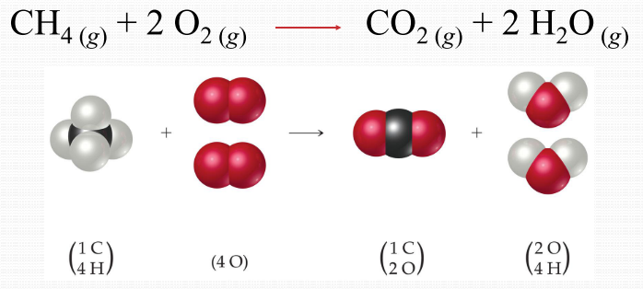

**Use of number in molecules;**

* The numbers at the bottom right indicate the number of atoms of each element in a molecule.
* The coefficients at the beginning of the element indicate the number of molecules.

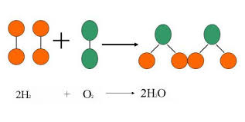

**Stoichiometric Balance;**

* A balanced equation must have the same number of atoms on the left side as on the right side.

**Percent Composition;**

* With this formula, you can find the percentage by mass of each of the elements in the compound.

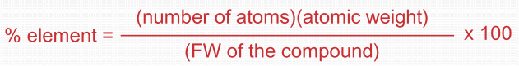

**Limiting Reactants;**

* The limiting reactant is the reactant that determines the amount of product in a reaction.
* The reaction will stop when all the limiting reactant is consumed.
* The limiting reactant helps calculate the theoretical yield of the reaction.

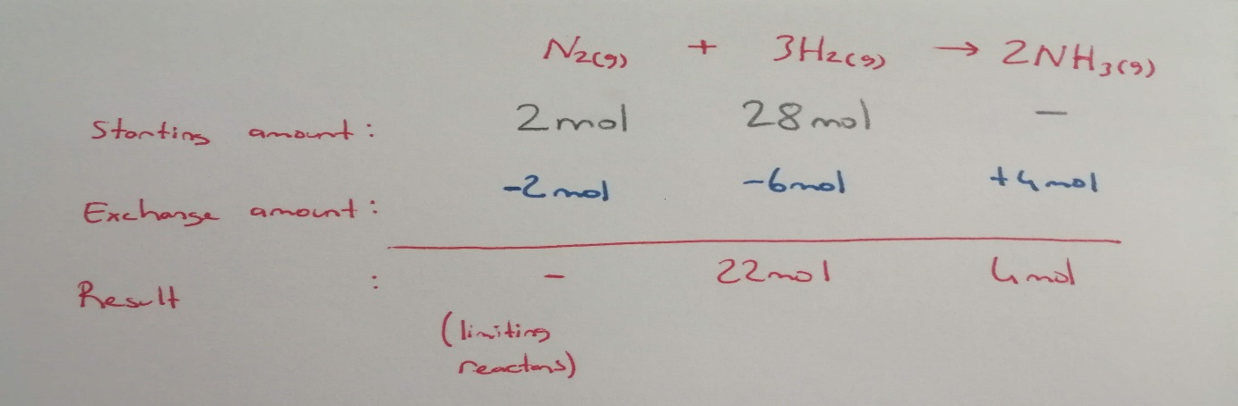

**Empirical, Molecular and Structural Formulas;**

* The empirical formula for a chemical compound is the simplest integer written for the atoms in the compound.
* Molecular formula is the spelling of the number of atoms in a molecule.
* Structural formulas describe the location of chemical bonds between atoms of a molecule

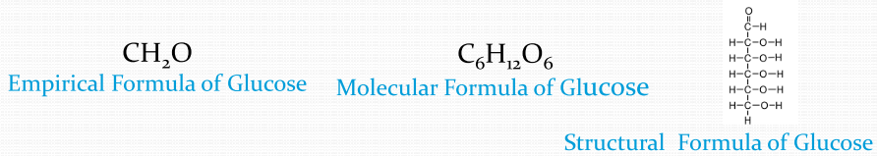

**Theoretical Yield;**

* Theoretical yield refers to how much product will be produced under ideal conditions.
* Actual yield refers to how much product is actually produced in the experiment.

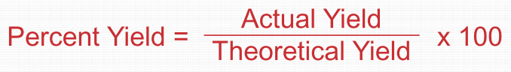

**Data of the experiment;**

**Part A;**

* Mass of test tube + Manganese dioxide (MnO2) (m1) >>> 15.92g
* Mass of test tube + Manganese dioxide (MnO2) + (KCIO3) (m2) >>> 17.02g
* Mass of test tube + Manganese dioxide (MnO2) + Residue (m3) >>> 16.59g

**Part B;**

* Mass of test tube + Manganese dioxide (MnO2) (m4) >>> 12.93g
* Mass of test tube + Manganese dioxide (MnO2) + Unknown (m5) >>> 13.93g
* Mass of test tube + Manganese dioxide (MnO2) + Residue (m6) >>> 13.70g

**Calculations of the experiment:**

metin içeren bir resim

Açıklama otomatik olarak oluşturuldu

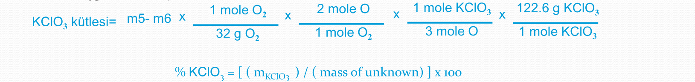

metin, beyaz tahta içeren bir resim

Açıklama otomatik olarak oluşturuldu

metin, beyaz tahta içeren bir resim

Açıklama otomatik olarak oluşturuldu

metin içeren bir resim

Açıklama otomatik olarak oluşturuldu

**Results of the experiment;**

Part A

Mass of oxygen lost: 0,43g

Mass of potassium chloride (residue)(KCI): 0,67g

Number of gram-atoms of oxygen evolved: 0.026 gram-atoms

Number of moles of KCI: 0,008 mol

Number of gram-atoms of K in original sample: 0,008 gram-atoms

Number of gram-atoms of CI in original sample: 0,008 gram-atoms

Number of gram-atoms of O in original sample: 0,024 gram-atoms

Simples formula of potassium chlorate: [K](https://tr.wikipedia.org/wiki/Potasyum)[Cl](https://tr.wikipedia.org/wiki/Klor)[O](https://tr.wikipedia.org/wiki/Oksijen)3

Part B

Mass of unknown mixture: 1,0g

Mass of oxygen lost: 0,2g

Number of gram-atoms of oxygen evolved: 0,0125gram-atoms

Number of moles of potassium chlorate decomposed: 0,004 mol

Mass of potassium chlorate in original sample: 0,510g

Percentage by weight of potassium chlorate in unknown: %51

The success we aim for in this experiment is to make a stoichiometric calculation using the conservation law of mass. In this experiment, our aim is to calculate what percentage by mass KCIO3 is in a mixture containing some KCIO3.

First, we heated the catalyst (MNO2) to room temperature to dehumidify the catalyst. Then we calculated the weight of the test tube and catalyst and then we added some KCIO3. We weighed again. We switched to the heating process and started the reaction.

We used this catalyst, as KCIO3 turns into KCl at lower temperatures with the help of this catalyst.

We kept the test tube inclined during the heating process to ensure a healthy gas outlet.

After the heating process was completed, we weighed again. With these mathematical values, we found the amount of oxygen flying and the amount of KCI remaining in the test tube. We proved the law of conservation of mass using equation.

Then we did a second reaction that was the same in the order of progression in the first reaction. We added some mixture next to the catalyst (it contains KCIO3). We weighed it again.

We know that there is a process change in the reaction and that the oxygen that turns into gas comes from KCIO3 only.

We switched to the heating process and started the reaction. After the heating process was completed, we weighed again.

With these mathematical values, we found the amount of gaseous oxygen and the percentage ratio of KCIO3 in the mixture.

To minimize errors in the experiment;

* Weighing precision is important to avoid errors during weighing.
* The moisture of the catalyst used in the reaction must be completely dried.
* If the weighing is done without 100% conversion in the reaction, wrong values ​​are taken.
* In the mixture used in the second experiment, only the KCIO3 needs to emit oxygen gas with the heating process, otherwise we get incorrect values.

When paying attention to these items, the test error rate will decrease.

**Questions & Answers:**

**1-**Write the balanced chemical equation for the reaction taking place when potassium chlorate is heated and a gas is evolved.

**2-**A mixture 40.0 % KCIO3 and 60.0 % NaCI was heated to constant weight. There was a loss of 0.720g of oxygen. Calculate:

**2a-**The weight of KCIO3 in the original mixture:

**2b-**The weight of sample which would have liberated 0.720g of oxygen:

**2c-**The percentage of chlorine in the residue:

**metin içeren bir resim

Açıklama otomatik olarak oluşturuldu**

**3-**How many moles of ferric oxide will be produced by the complete oxidation of 100g of iron?

4Fe + 3O2 ----🡪 2 Fe2O3

**4-**When 50.0g of calcium is mixed with 30.0g of oxygen, a reaction takes place in which calcium reacts oxygen to form CaO.

**4a-**Write the balanced equation for the reaction.

**4b-**Calculate the weight of CaO produced.

**4c-**Which of the two reactants is in excess, and by what weight?

**metin içeren bir resim

Açıklama otomatik olarak oluşturuldu**

**5-** Why is it important to write down the states of matter (molecules) in a chemical reaction?

We specify the physical states of the substance in the reaction to use in stoichiometry calculations. For example, if we do not write that one of the products formed as a result of a reaction is in a gaseous state, we can make mistakes in processes using the law of conservation of mass.

**Referenced sources:**

Websites:

<https://tr.wikipedia.org/>

<http://www.kimyaevi.org/>

<https://www.greelane.com/>

Books:

General Chemistry Principles and Modern Applications (10th Edition, Chapter 2).